

A better tomorrow

PART THREE



June 30, 2023

Katelyn Narain

ST10311395

Table of Contents

PART 1 2

About 2

Assets 3

Pictures 6

Website Pages and Content 7

Part 2 9

Improvements to part 1 document 9

Website Pages and Content 9

Improvements to part 1 website 11

Part 3 15

Improvements to part 2 document 15

Improvements to Part 2 website 15

Functionality 17

SEO 19

### PART 1

### About

**A New Tomorrow**

A New Tomorrow, will be an organization that will help South Africa’s economy in some sort of way by make use of our resources that we already have but don’t use. To develop transformative strategies for town’s and neighborhood’s. Work hand-in-hand with residents, civil society entities, faith-based institutions, business, all levels of government, academic institutions and local change agents to co-create places where people can prosper.

My objective to create healthy eco-systems that lay a foundation for optimal development. Rather than destroying and erasing, places are preserved and given new meaning, providing that brave renovations and restorations have the power to change communities, neighborhoods and cities. A transformed place has the power to transform lives. Through collaboration, we tackle what is wrong and unlock what is strong. Explores the power of abandoned traversing history and narratives through the decrepit walls of long forgotten and lost structures. Not only does this NGO look to the past, it looks towards the future, examining the extraordinary ways lost architecture can be reimagined and repurposed. Abandoned buildings such as old abandoned hospitals, churches, military sites that could be turned into museums, free markets, park, activities for fun and games, shelter for homeless, not only the community but also could be potential tourist attractions.

Abandoned buildings present a unique opportunity for resourceful individuals, communities and governments to repurpose them for a range of different uses. Some of the most common structures include old factories, schools, hospitals and commercial buildings. Many of the buildings have be abandoned for years, and they often fall into disrepair and become eyesores in local communities. However, by making use of abandoned buildings, we can not only restore their beauty but also create practical benefits that can help individuals and communities.

A New Tomorrow will be an organization that makes use of abandoned buildings by doing them up and saving them only to benefit the community around it.

### Assets

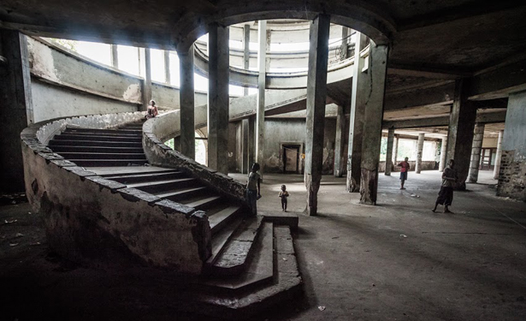

Figure 1: Abandoned Grande Hotel Beira, Mozambique,

n.d. (Source: [Sokhin](https://www.theatlantic.com/international/archive/2013/01/in-mozambique-a-glorious-inn-becomes-a-slum/272533/), n.d. : online)

[Sokhin](https://www.theatlantic.com/international/archive/2013/01/in-mozambique-a-glorious-inn-becomes-a-slum/272533/), V. (n.d) *Abandoned Grande Hotel Beira, Mozambique, n.d.* [online image][Accessed on the 24th March 2023] <https://filmfixers.co.za/2020/05/03/top-10-abandoned-locations/>

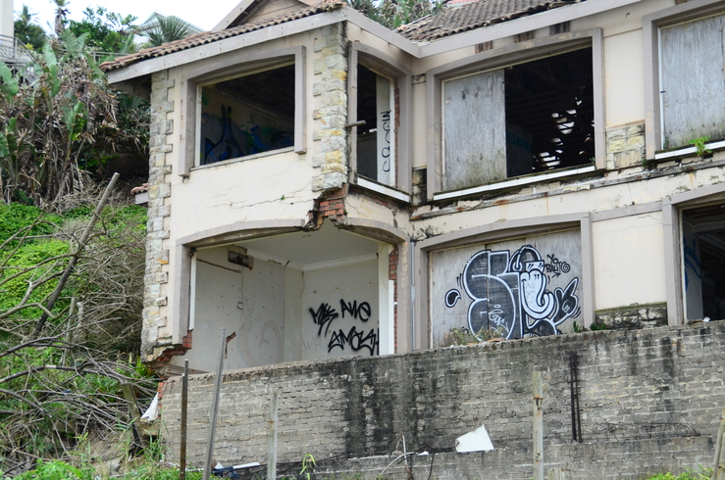

Figure 2: Abandoned Ballito house, Ballito, April 11

2018. (Source: Abrahams, 2018: online)

Abrahams, E. (2018) *Abandoned Ballito house, Ballito, April 11 2018*. [online image][Accessed on the 24th March 2023] <https://northcoastcourier.co.za/106515/abandoned-ballito-house-must-go/>

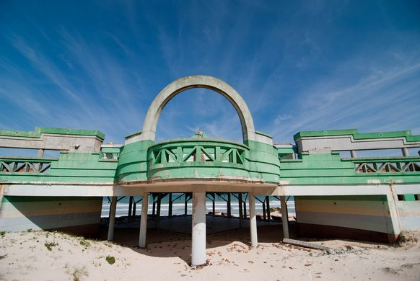

Figure 3: Macassar Beach Pavilion, Cape Town, August

20 2013. (Source: Bischoff, 2013: online)

Bischoff, A. (2013) *Macassar Beach Pavilion, Cape Town, August 20 2013.* [online image][Accessed on the 14th March 2023] <https://www.atlasobscura.com/places/macassar-beach-pavilion>

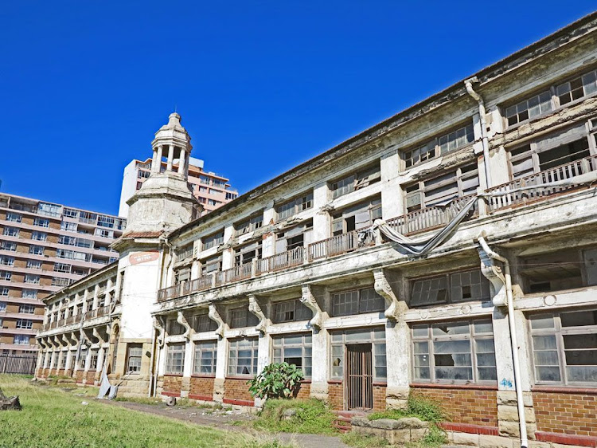

Figure 4: Addington Children’s Hospital, Durban,

October 15 2019. (Source: Botha, 2019: online)

Botha, C. (2019) *Addington Children’s Hospital, Durban, October 15 2019.* [online image][Accessed on the 14th March 2023) <https://www.wantedonline.co.za/art-design/2019-09-17-repurposed-or-ruined-the-lost-grandeur-of-durbans-historical-architecture/>

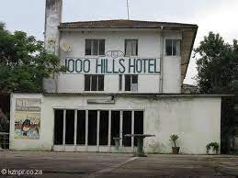

Figure 5: 1000 Hills Hotel, Umgeni, n.d. (Source: KZNPR,

n.d: online)

KZNPR. (n.d) : *1000 Hills Hotel, Umgeni, n.d.* [online image][accessed on the 14th March 2023] <https://kznpr.co.za/drummond-inchanga/>

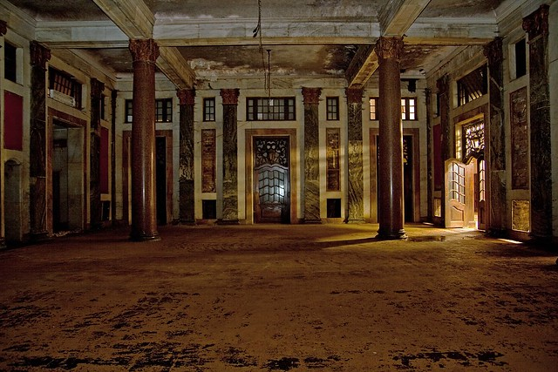

Figure 6: Park Station, Johannesburg, n.d. (Source: Smith, n.d:

Online)

Smith, D. (n.d): *Park Station, Johannesburg, n.d.* [online image][accessed on the 14th March 2023][*https://filmfixers.co.za/2020/05/03/top-10-abandoned-locations/*](https://filmfixers.co.za/2020/05/03/top-10-abandoned-locations/)

### Pictures

#### Logo

designed using LOGO Maker app <https://play.google.com/store/apps/details?id=com.TTT.logomaker.logocreator.generator.designer&hl=en&gl=US>

#### Pictures taken out myself:

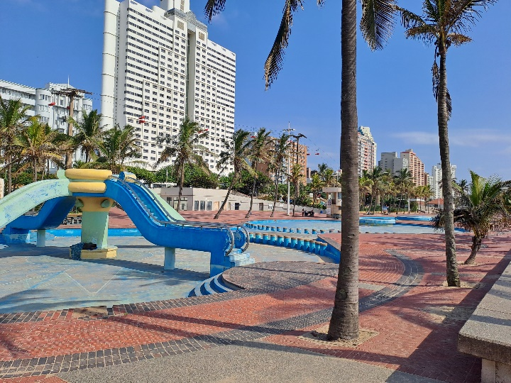

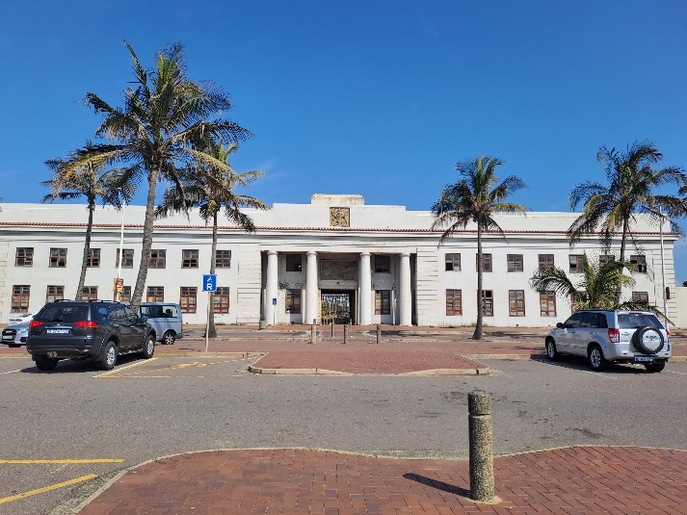

### Website Pages and Content

1. Home
2. Logo
3. Name of organization
4. Slogan
5. Links to other pages
6. Heading (Description:)
7. Summary of main activities of the organization
8. Copyright and year
9. About
10. Logo
11. Organization name
12. Slogan
13. Links to other pages
14. Heading (About us:)
15. Summary about the activity of the organization
16. In Future the pictures of the organization work
17. Gallery
18. Logo
19. Organization name
20. Slogan
21. Links to other pages
22. Pictures of abandoned buildings
23. Name and location of abandoned buildings
24. Sources of imagine
25. Contact
26. Logo
27. Organization name
28. Slogan
29. Links to other pages
30. Contact details for: telephone, cellphone, email, Instagram, Facebook
31. Services
32. Logo
33. Organization name
34. Slogan
35. Links to other pages
36. Description on our ideas
37. Donate
38. Logo
39. Organization name
40. Slogan
41. Links to other pages
42. Bank details

### Part 2

### Improvements to part 1 document

### Website Pages and Content

1. Home
2. Logo of company
3. Name of organization – Better tomorrow.
4. Slogan- inspired by dreams.
5. Links to other pages- about, gallery, service, donate, contact.
6. Heading (Description:)
7. Summary of main activities of the organization
8. Copyright and year
9. About
10. Logo of company.
11. Organization name- Better tomorrow
12. Slogan –inspired by dreams.
13. Links to other pages- home, gallery, service, donate, contact.
14. Heading (About us:)
15. Summary about the activity of the organization
16. In Future the pictures of the organization work
17. Gallery
18. Logo of company.
19. Organization name- Better tomorrow.
20. Slogan-inspired by dreams.
21. Links to other pages- home, about, service, donate, contact.
22. Pictures of abandoned buildings
23. Name and location of abandoned buildings
24. Sources of imagine
25. Contact
26. Logo of company.
27. Organization name - Better tomorrow.
28. Slogan-inspired by dreams.
29. Links to other pages-- home, about, gallery, service, donate.
30. Contact details for: telephone, cellphone, email, Instagram, Facebook
31. Services
32. Logo of company.
33. Organization name- Better tomorrow.
34. Slogan- inspired by dreams.
35. Links to other pages-- home, about, gallery, contact, donate.
36. Description on our ideas
37. Donate
38. Logo of company.
39. Organization name-Better tomorrow.
40. Slogan- inspired by dreams.
41. Links to other pages-- home, about, gallery, service, contact.
42. Bank details

### Improvements to part 1 website

#### HTML

**1)Homepage:**

* In lines 10 I added  <link rel="stylesheet" type="text/css" href="home.css"> to link css to Home page.
* In line 11 I added  <link rel="stylesheet" href=<https://cdnjs.cloudflare.com/ajax/libs/font-awesome/4.7.0/css/font-awesome.min.css> for icons in my tabs.

**My topnav:**

* I added comments for all code.
* in my <Style>, I removed lines 22.
* In line 35 I added <div class= “row” for css responsive.
* In lines 36 I added ”col-3 col-s-3 menu"> for css responsive.
* In lines 38 to 44 I added  <ul> <li> to my links to my other pages</li> </ul> for layout.

**My middle column:**

* In line 46 I changed my class name from <div class=”middle-column”> to <div class="col-6 col-s-9"> for css responsive.
* In line 71 I added <div class="col-3 col-s-12"> for css responsive.
* In line 72 I added <div class="aside"> for css responsive.
* in lines 73 to 76 I added <video> for a video in my homepage.

**My footer:**

* No improvements were made in html.

**2)About Page:**

* in lines 10 I added  <link rel="stylesheet" type="text/css" href="home.css"> to link css to about page.
* In line 11 I added  <link rel="stylesheet" href=<https://cdnjs.cloudflare.com/ajax/libs/font-awesome/4.7.0/css/font-awesome.min.css> for icons in my tabs.

**My topnav:**

* I added comments for all code.
* In line 36 I added <div class= “row” for css responsive.
* In lines 37 I added ”col-3 col-s-3 menu"> for css responsive.
* In lines 38 to 44 I added  <ul> <li> to my links to my other pages</li> </ul> for layout.

**My middle column:**

* In line 47 I changed my class name from <div class=”middle-column”> to <div class="col-6 col-s-9"> for css responsive.

**My footer:**

* No improvements were made in html.

**3)Gallery page:**

* In lines 10 I added  <link rel="stylesheet" type="text/css" href="home.css"> to link css to gallery page.
* In line 11 I added  <link rel="stylesheet" href=<https://cdnjs.cloudflare.com/ajax/libs/font-awesome/4.7.0/css/font-awesome.min.css> for icons in my tabs.

**My topnav:**

* I added comments for all code.
* In line 48 I added <div class= “row” for css responsive.
* In lines 39 I added ”col-3 col-s-3 menu"> for css responsive.
* In lines 50 to 56 I added  <ul> <li> to my links to my other pages</li> </ul> for layout.

**My middle column:**

* In line 59 I changed my class name from <div class=”middle-column”> to <div class="col-6 col-s-9"> for css responsive.

**My Footer:**

* No improvements were made in html.

**4)Service Page:**

* In lines 10 I added  <link rel="stylesheet" type="text/css" href="home.css"> to link css to service page.
* In line 11 I added  <link rel="stylesheet" href=<https://cdnjs.cloudflare.com/ajax/libs/font-awesome/4.7.0/css/font-awesome.min.css> for icons in my tabs.

**My topnav:**

* I added comments for all code.
* In line 36 I added <div class= “row” for css responsive.
* In lines 37 I added ”col-3 col-s-3 menu"> for css responsive.
* In lines 38 to 44 I added  <ul> <li> to my links to my other pages</li> </ul> for layout.

**My middle column:**

* In line 47 I changed my class name from <div class=”middle-column”> to <div class="col-6 col-s-9"> for css responsive.

**My Footer:**

* No improvements were made in html.

**5)Donate page**

* In lines 10 I added  <link rel="stylesheet" type="text/css" href="home.css"> to link css to donate page.
* In line 11 I added  <link rel="stylesheet" href=<https://cdnjs.cloudflare.com/ajax/libs/font-awesome/4.7.0/css/font-awesome.min.css> for icons in my tabs.

**My topnav:**

* I added comments for all code.
* In line 36 I added <div class= “row” for css responsive.
* In lines 37 I added ”col-3 col-s-3 menu"> for css responsive.
* In lines 38 to 44 I added  <ul> <li> to my links to my other pages</li> </ul> for layout.

**My middle column:**

* In line 47 I changed my class name from <div class=”middle-column”> to <div class="col-6 col-s-9"> for css responsive.

**My Footer:**

* No improvements were made in html.

#### CSS

* I deleted all other css files and linked all files to one root css file home.css.
* line 1 -3 (box-sizing: border-box) added styling to boxes.
* in line 5-9 (row::after) added to style the tabs for links to other pages.
* in lines 11-14 ( [class*=”col=”] added responsive.
* in lines 16-18(html) added font style for website.
* in lines 20-25(header) added the background and color for company name.
* in lines 27-31 (menu ul) added the position for the tabs
* in lines 33-39(menu li) added the size and color for tabs.
* in lines 41-44(menu li:hover) added color to tab when mouse goes over it.
* in lines 46-50(aside) add measurements.
* in lines 53-59(footer) styling of footer.
* in lines 61-64([class*=”col-“]) responsive for mobile phones.
* in lines 66-80(@media only screen and (min-width: 600px) responsive for tablets.
* in lines 81-95(@media only screen and (min-width: 769px) responsive for desktops.

### Part 3

### Improvements to part 2 document

No improvements were needed in word document.

### Improvements to Part 2 website

#### HTML

**1)Homepage:**

**My middle column:**

* in lines 74 to 83 I added JavaScript to better user experience.
* in line 74 I added “class=” for responsive.

**My Footer:**

* in line 97 I added a Google Form.

<iframe src="https://docs.google.com/forms/d/e/1FAIpQLSdGacIQOUCM12NUMPBUGrEhwSIZv366wRzzcmJxdBf6Q1oAZQ/viewform?embedded=true" width="500" height="200" frameborder="0" marginheight="0" marginwidth="0">Loading…</iframe>

**2)About page:**

no changes were made

**3)Gallery Page**

**My Style**

* in lines 25, in style, I changed h5 tag to h2 tag for seo.
* in line 32, in style, I changed h6 tag to h3 tag for seo .

**My Middle Column**

* in lines 64, 69, 75, 80, 85, 90, 95 and 100 I changed h5 tag to h2 tag for seo.
* in lines 65, 70, 76, 81, 86, 91, and 101 I changed h6 tag to h3.

**4)Contact Page**

**Style**

* in line 26 I changed border style from “darkcyan” to “purple”.

**My Middle column**

* I added a html form.

**5) Service page**

no changes were made.

**6)Donate page**

no changes were made.

#### CSS

* in line 18 I added a background image to my website.
* in lines 20 I added background size to cover website.
* in lines 57 to 61 I added an id “#Content” for styling.
* in line 58 I added a border.
* in line 59 I added a background colour for the reader to easily read content.
* in line 60 I added border-radius.
* in lines 63 to 67 I added an id “#Aboutus” for styling.
* in line 64 I added a border.
* in lines 65 I added a background colour for the reader to easily read content.
* in line 66 I added a border-radius.
* in lines 69 to 78 I added an id ”#factButton” to style fact button.
* in lines 81 to 85 I added an id “#contact” for styling.
* in line 82 I added a border.
* in lines 83 I added a background colour for the reader to easily read content.
* in line 84 I added a border-radius.
* in lines 87 to 91 I added an id “#survey” for styling.
* in line 88 I added a border.
* in lines 89 I added a background colour for the reader to easily read content.
* in line 90 I added a border-radius.
* in lines 93 to 97 I added an id “#service” for styling.
* in line 94 I added a border.
* in lines 95 I added a background colour for the reader to easily read content.
* in lines 97 I added a border-radius.
* in lines 99 to 103 I added an id “#donate” for styling.
* in line 100 I added a border.
* in lines 101 I added a background colour for the reader to easily read content.
* in lines 102 I added a border-radius.

### Functionality

Added JavaScript in homepage lines 74 to 83

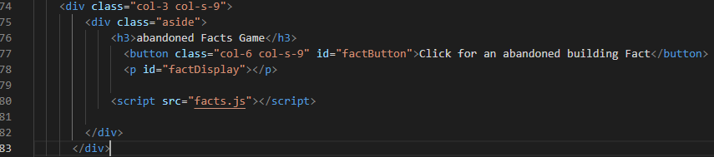

in line 80 <script> tag was added to link facts.js to html



Facts.js was added to add JavaScript.



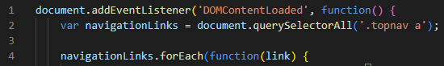

Remove the “active” class from all links



add the “active” class to the clicked link



add custom logic or actions here



create an array of quotes and a variable to store the array

a normal string array

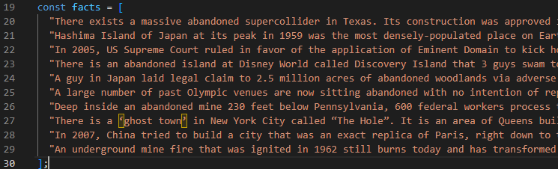

Create variables and assign IDs



create a function



create a new variable and use the math.random method

facts.length counts the characters stored in the arrays

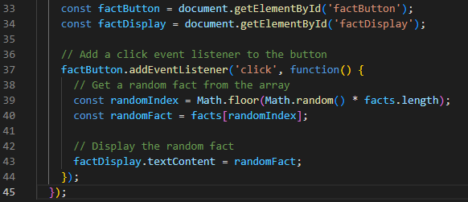

### SEO

* **Title tags** are not too long

**Homepage**

in line 7 <title>Home</title>

**About page**

in line 7<title>About</title>

**Gallery Page**

in line 7 <title>Gallery</title>

**Service Page**

in line 7 <title>Service</title>

**Contact Page**

in line 7 <title>Contact</title>

**Donate Page**

in line 7 <title>Donate</title>

* all **headings tags** are in h1, h2, h3

**Homepage**



**About Page**



**Gallery Page**



















**Contact Page**



**Service Page**



**Donate Page**



* **Alt text** for images, inserting some relevant keywords while accurately describing the imae will help search engines understand my page’s content.

**Homepage, About, Contact, Donate, Service, Gallery**

“Logo” to indicate that is my NGO logo

**Gallery**

To indicate what is in the image:

“Command” line 63

“Building” line 68

“Pool” line 74

“Hospital” line79

“House” line 84

“Beach” in line 89

“Hotel” line 94

“Park-station” line 99

* URL

Just one url link: http://127.0.0.1:5500/home.html

* PageSpeed

minifying JS, CSS and HTML